Step by Step guide to Setup AWS RDS (Postgres)

Step 1: Login AWS Dashboard

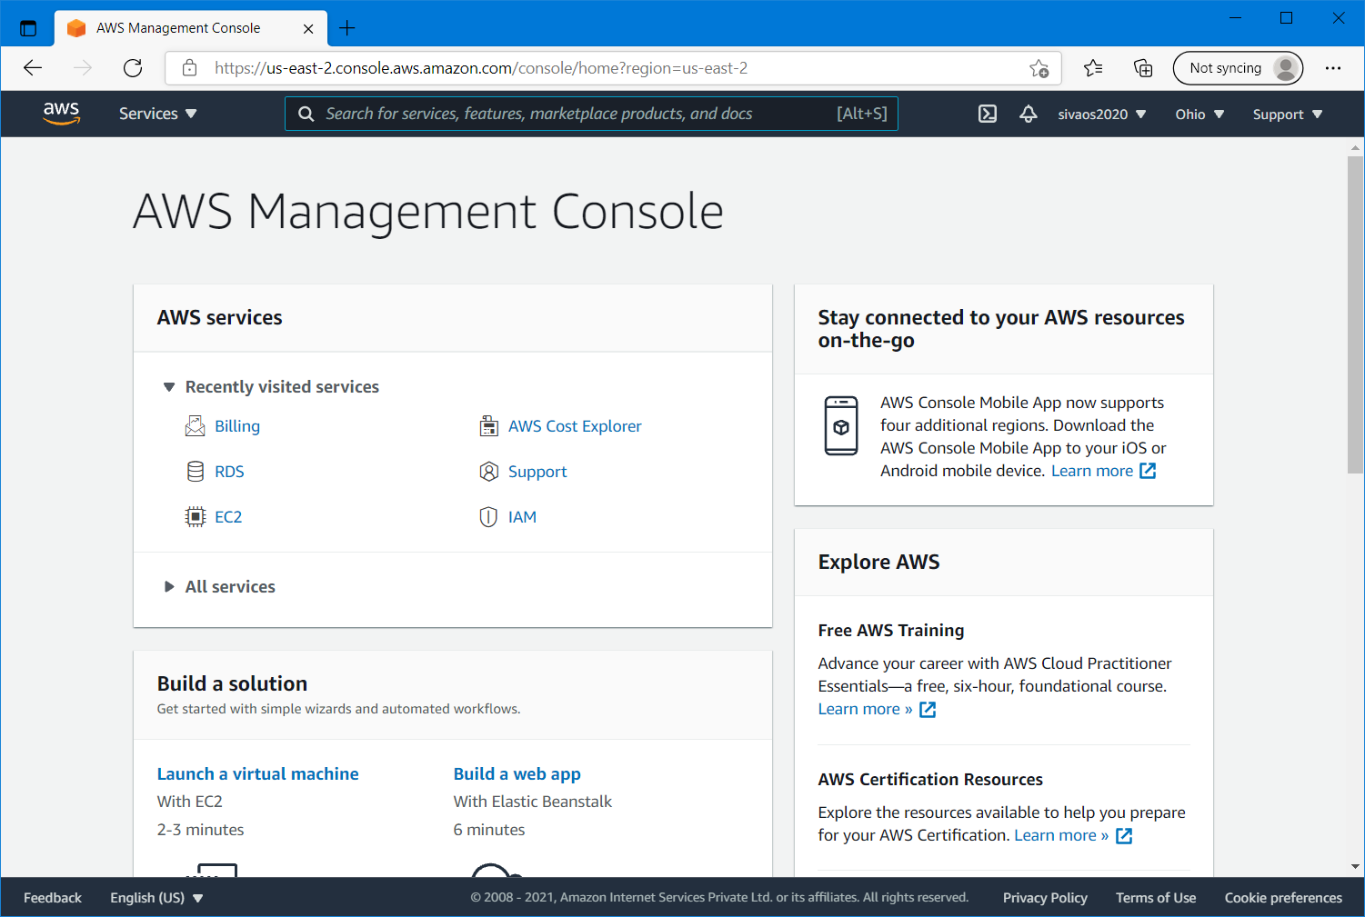

Step 2: Select RDS in the Services dropdown menu.

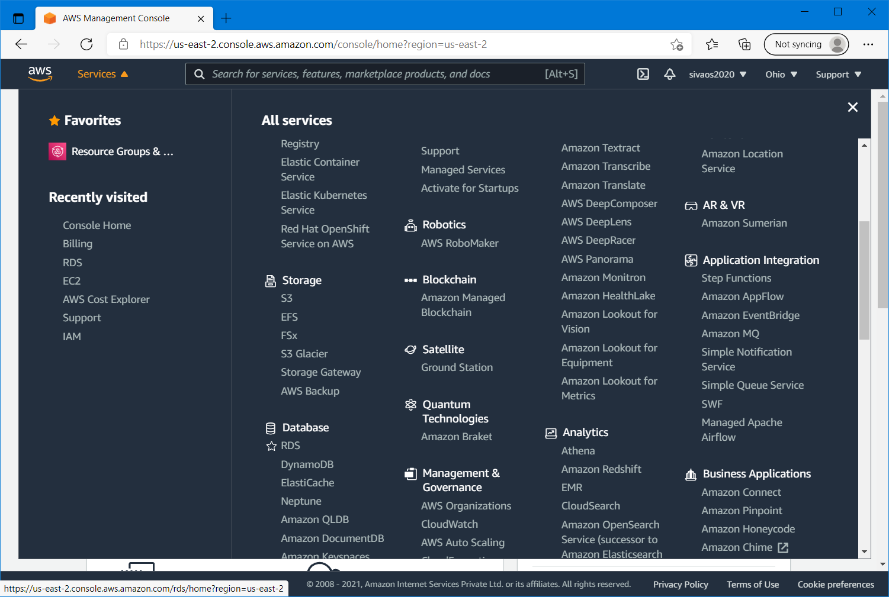

Step 3: Click on “Create Database” button

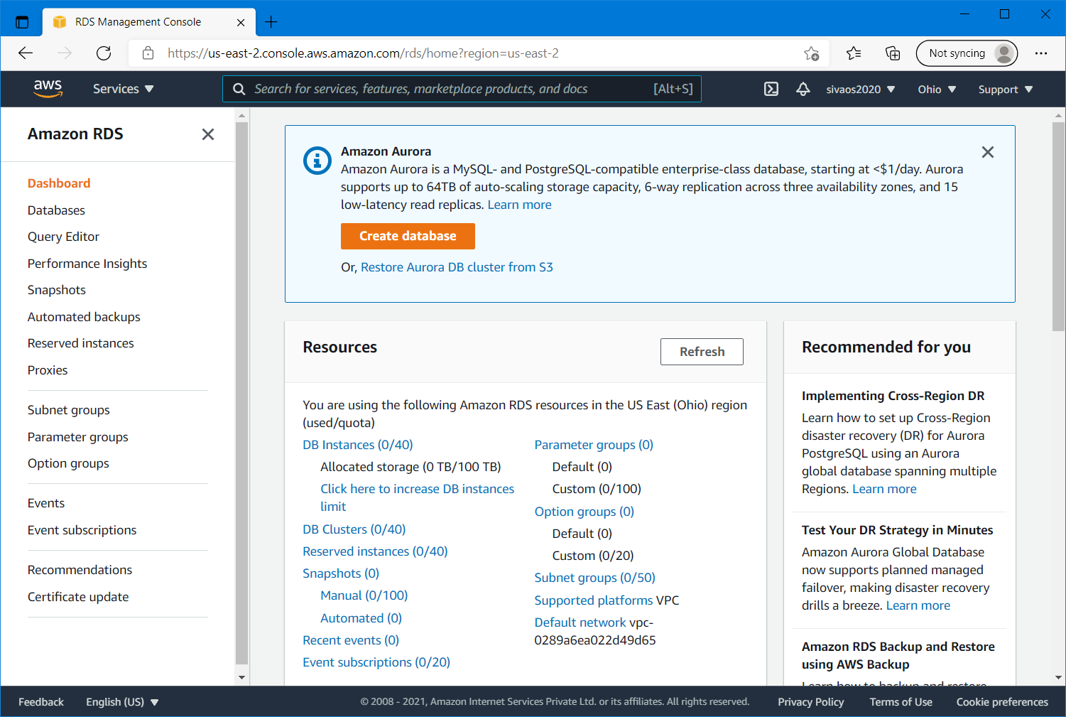

Step 4: select “Standard Create” option and “PostgreSQL 12.6-R1” version in the dropdown menu as shown below

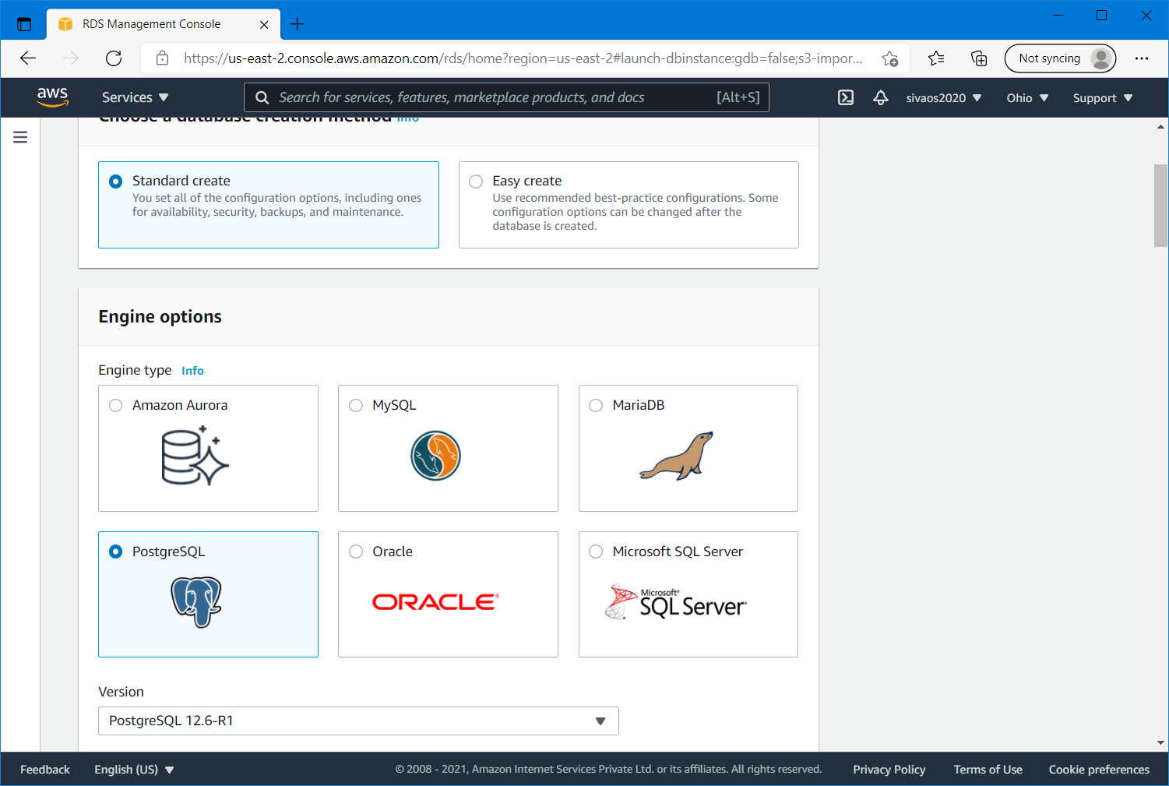

Step 5: Select the “FreeTier” option in the radio button and type DB instance identifier as “revature” as shown below. Leave the Master username as “postgres” and add Master password as “postgres”

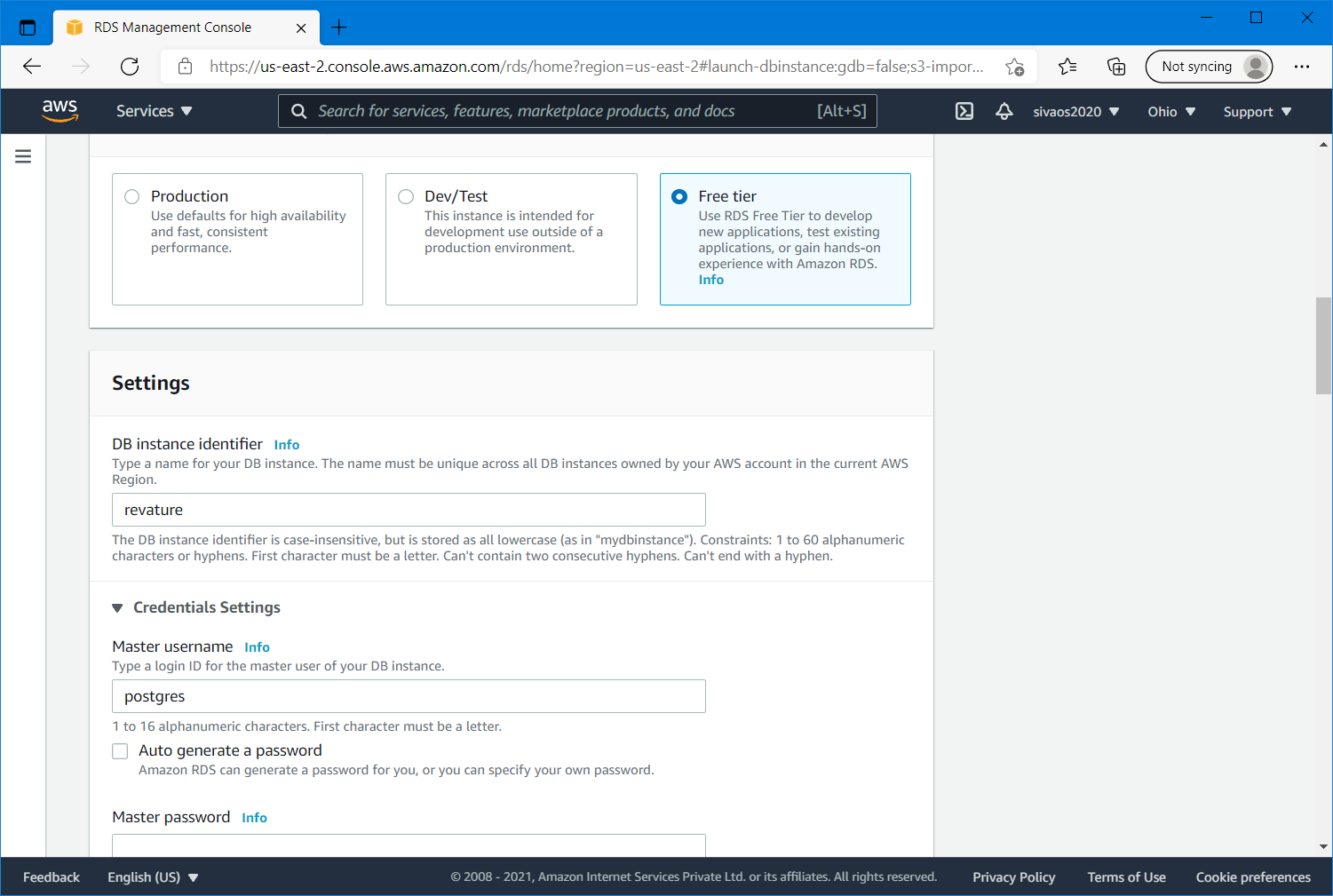

Step 6: Leave the DB Instance type as it is “Burstable classes (includes t classes)” db.t2.micro

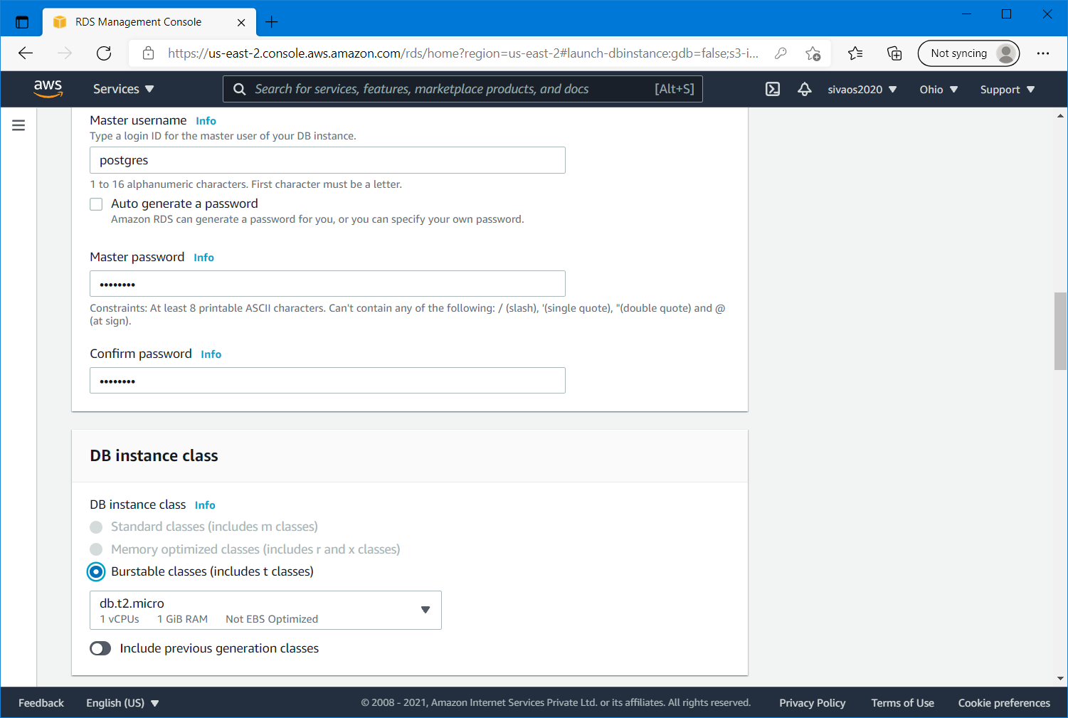

Step 7: select the Storage type as “General Purpose SSD(gp2)” and Allocated storage as it is (20GiB)

And remember to remove the check box for “Enable storage autoscaling”

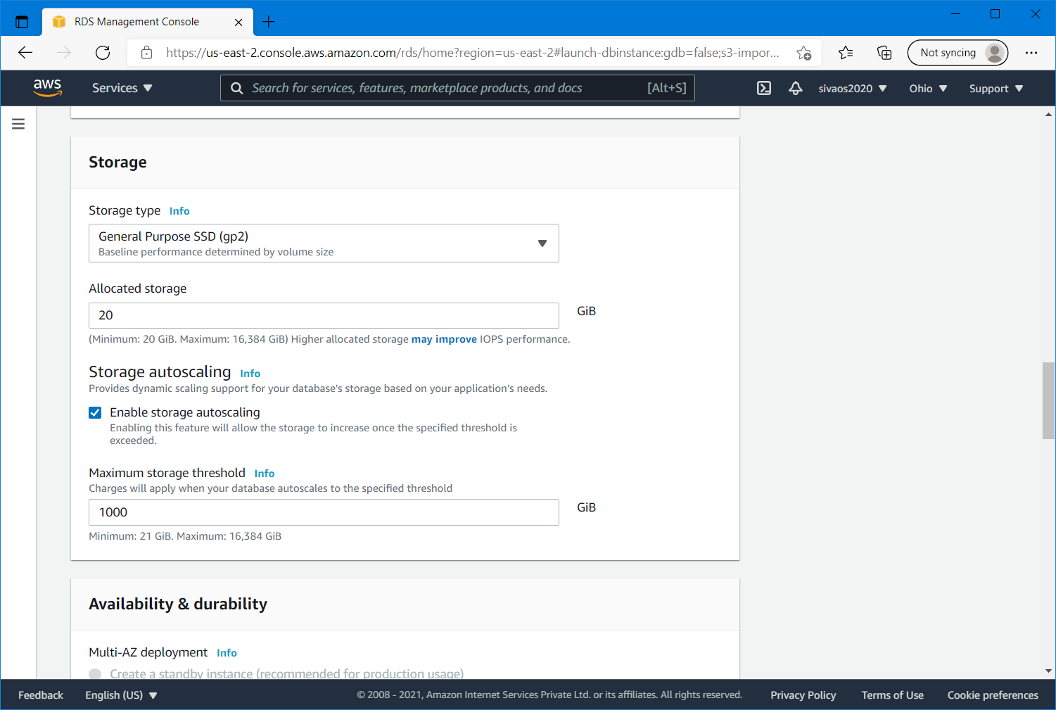

Step 8: In the Connectivity settings, leave the default VPC and default Subnet group as it is.

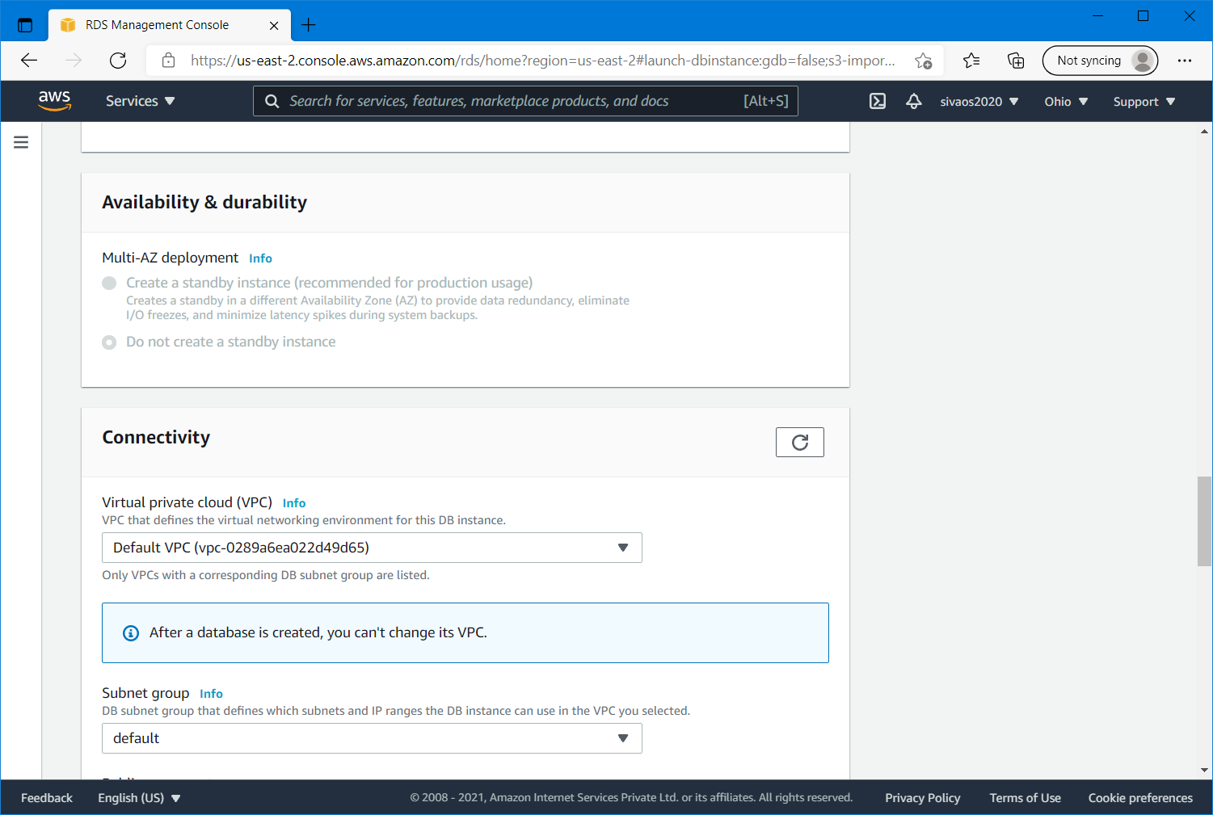

Step 9: Select “Yes” for Public access and make sure “default” is selected for VPC security group, No preference for Availability Zone.

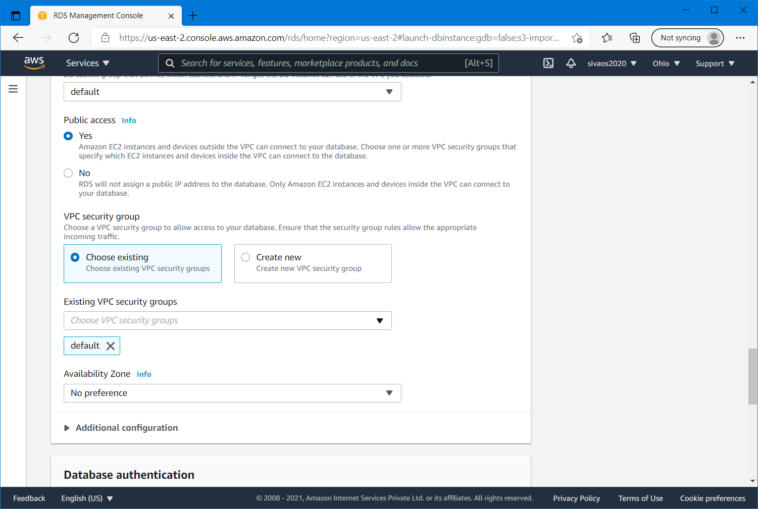

Step 10: In the Additional configuration leave the Database port as 5432 for TCP/IP port and leave the “Password authentication” for Database authentication

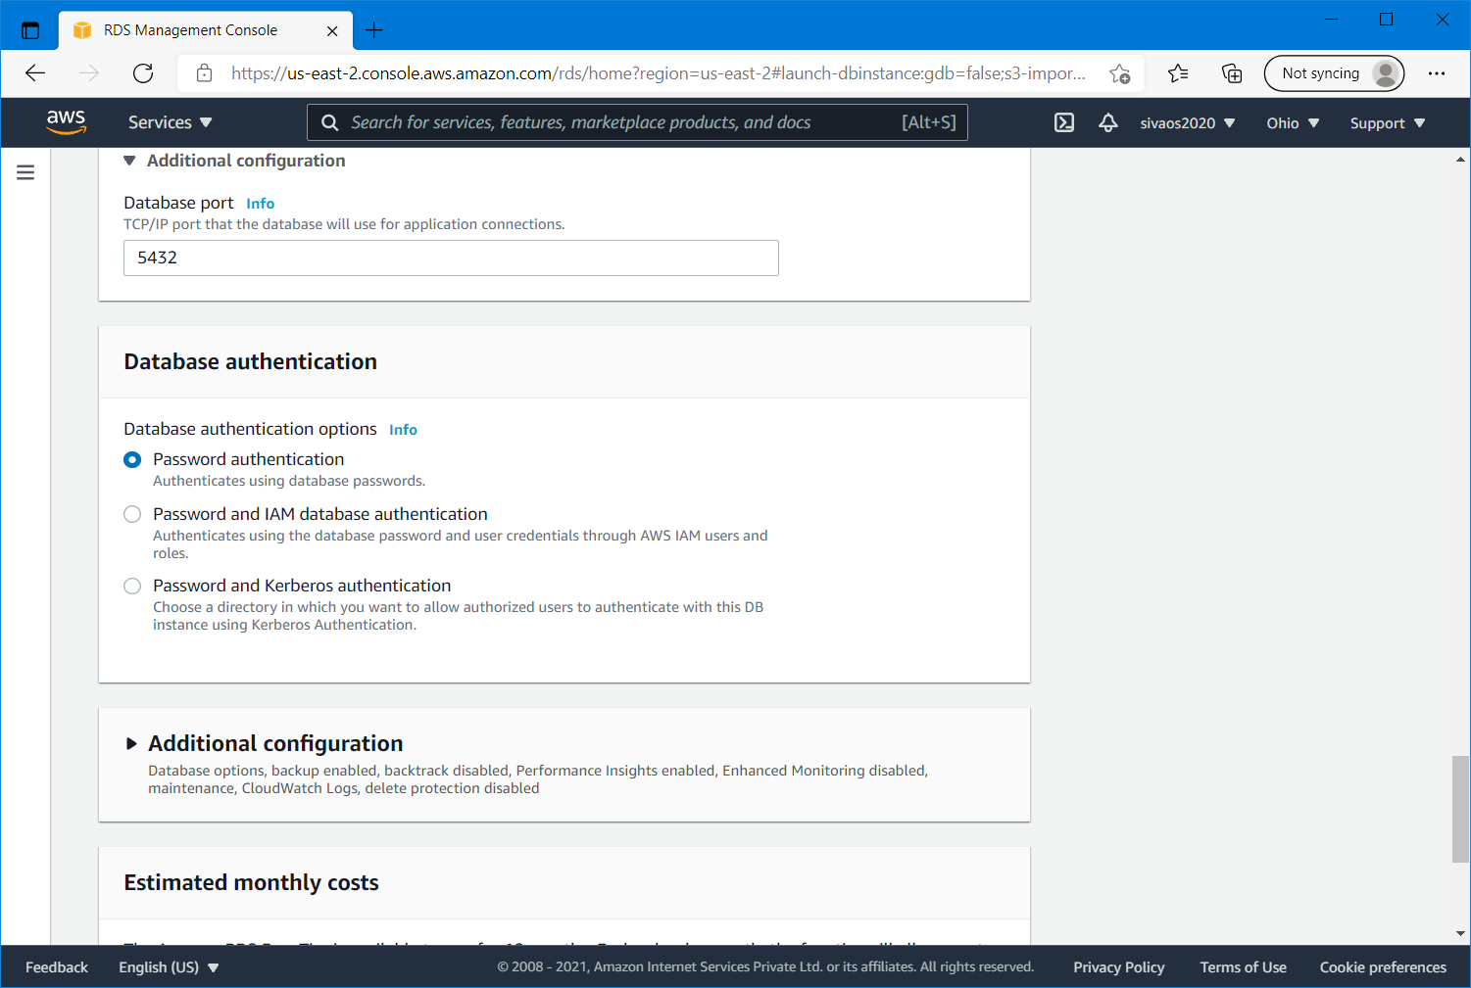

Step 11: Expand “Additional configuration”, type Initial database name as “postgres”, leave the DB parameter group as it is and uncheck “Enable automated backups &Enable Performance Insights” checkboxes.

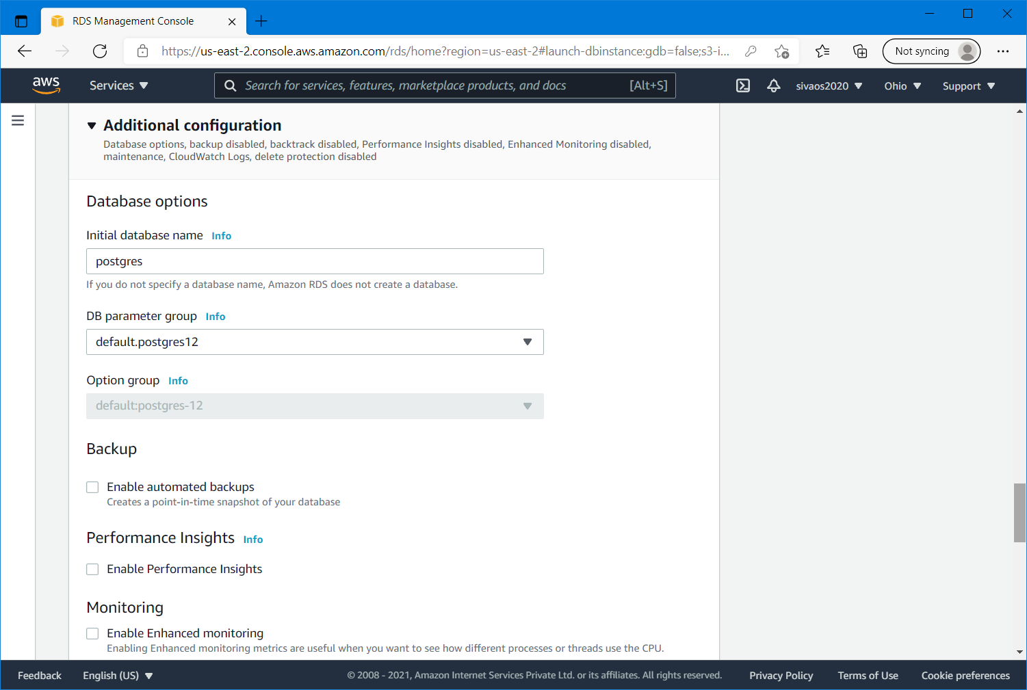

Step 12: In the Maintenance section uncheck “Enable auto minor version upgrade” and leave the “No preference” for Maintenance window

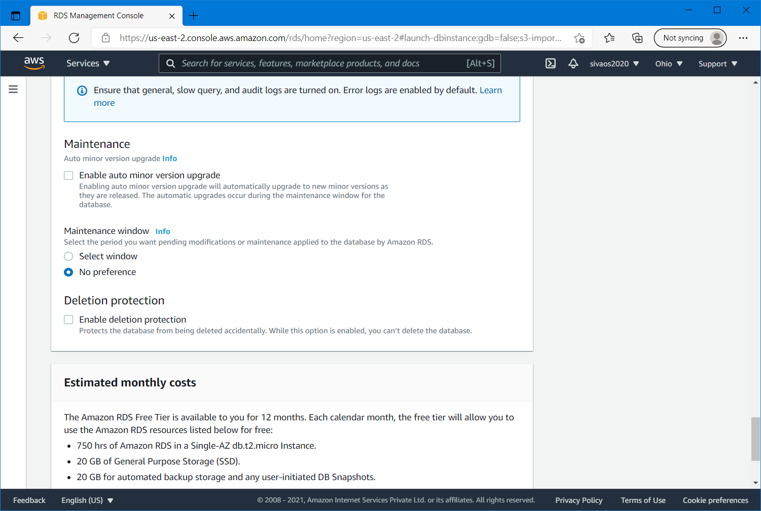

Step 13: Make sure “Enable delete protection” is not selected and click on “Create database” button.

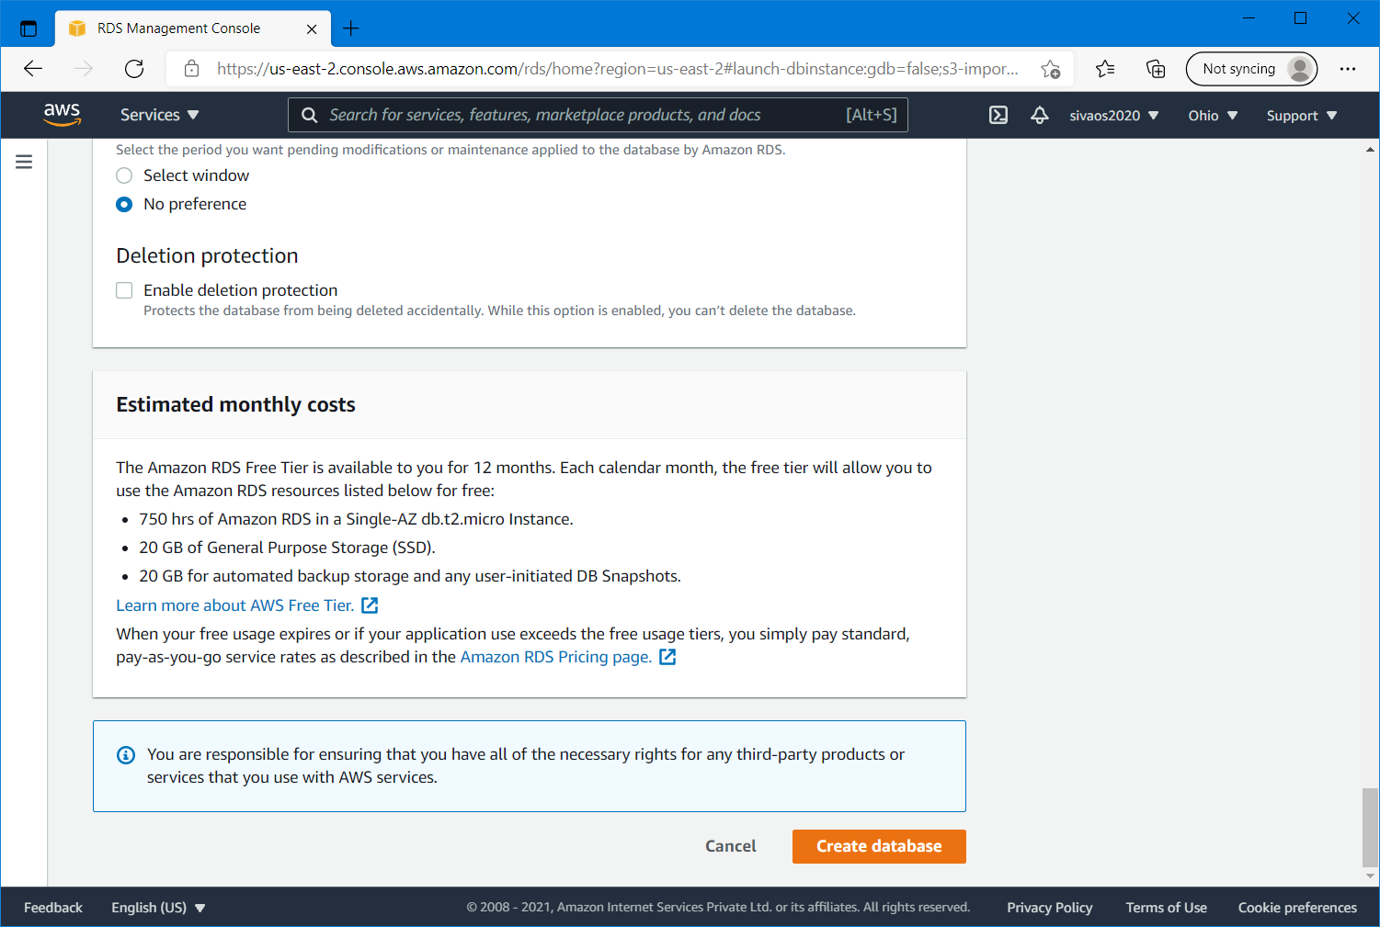

Step 14: It will take some time to create the RDS, you can see a message “Creating database revature” as shown below.

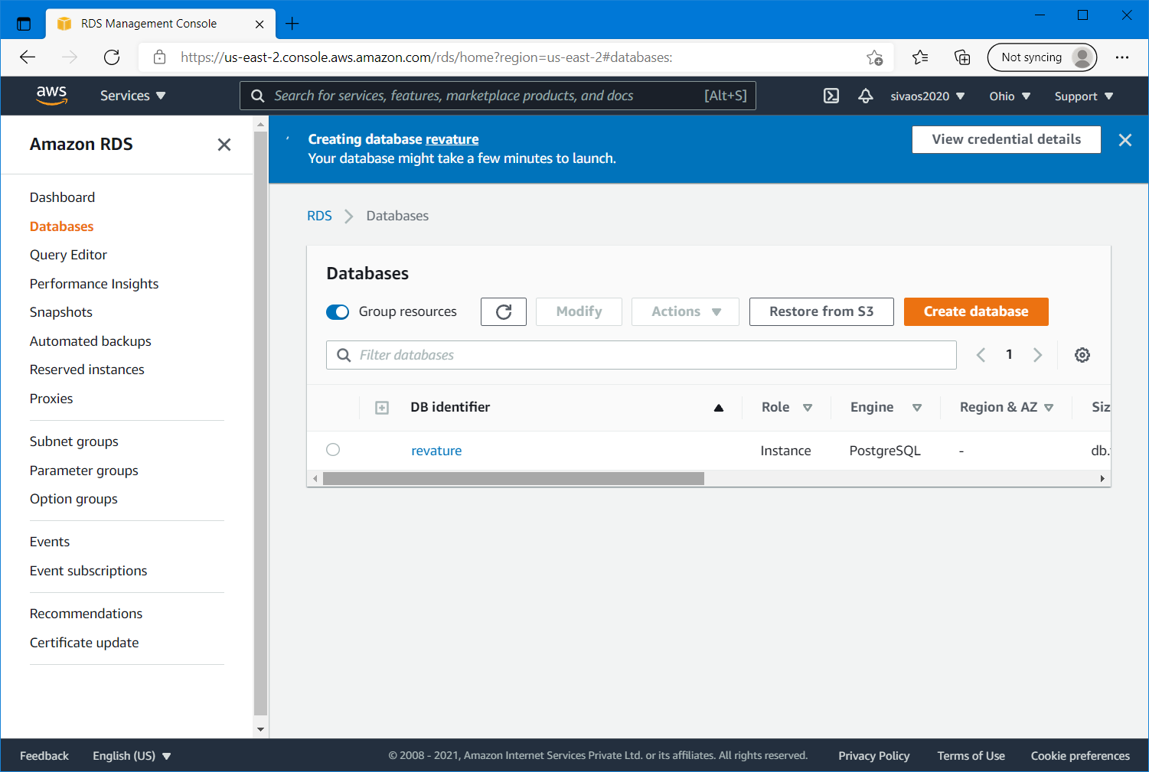

Step 15: Once it is created, click on “View connection details”

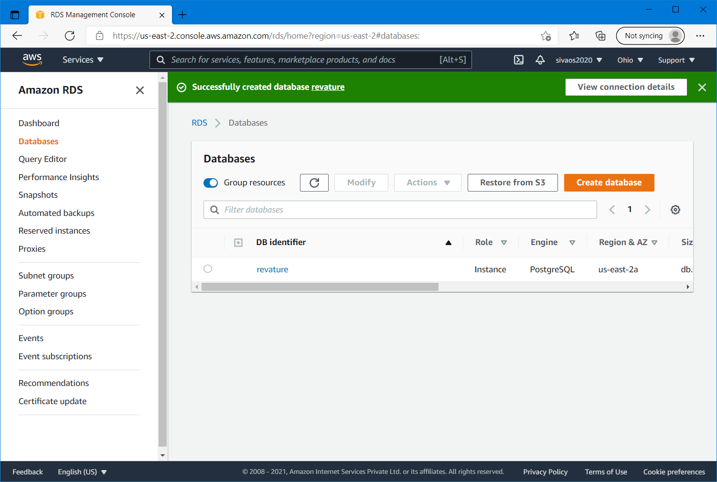

Step 16: Copy the endpoint and password for your database instance

The End point looks like the following

<db_instance_identifier>.<random_alphanumeric_char>.us-east-2.rds.amazonaws.com

Step 17: By clicking the Db identifier, open the database details and select the default inbound security group

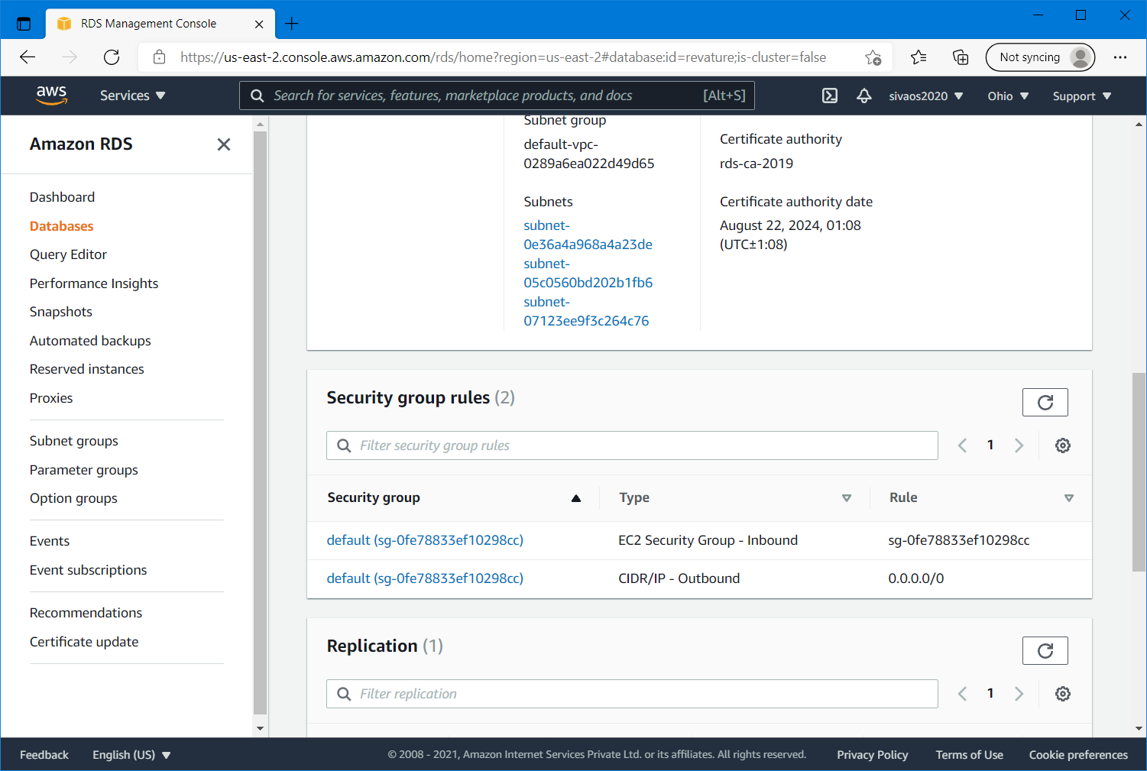

Step 18: select the “inbound rules” section click on “Edit inbound rules” option

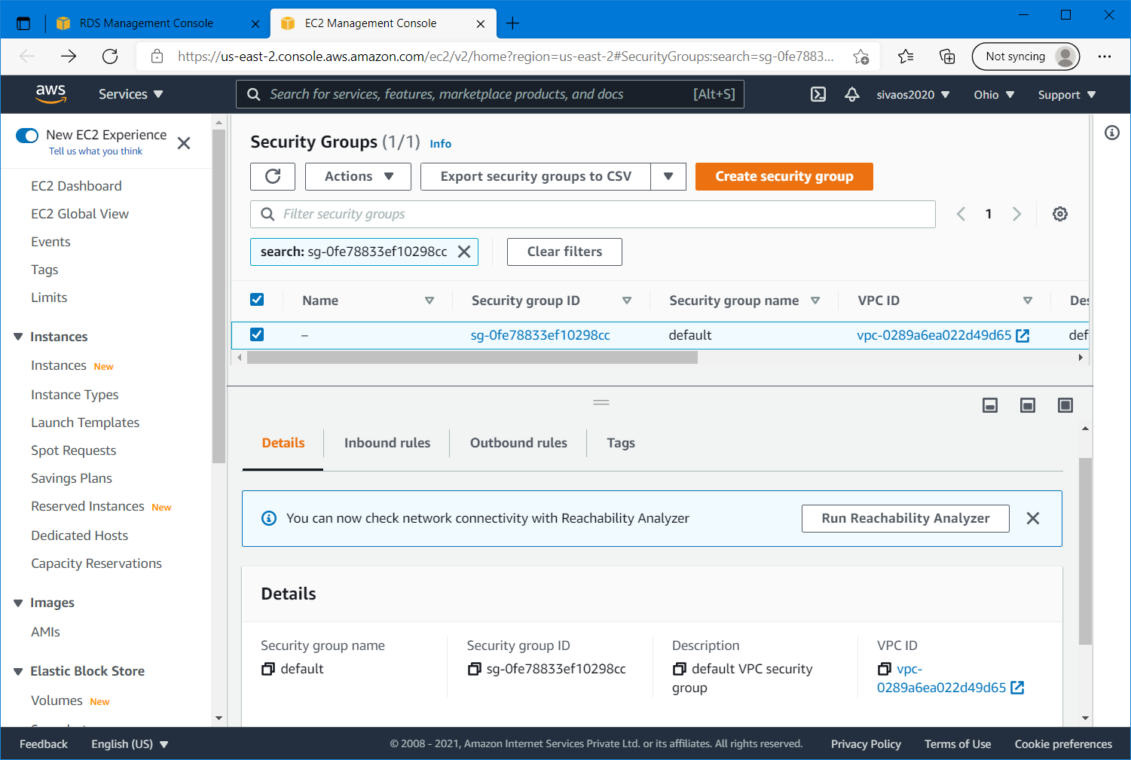

Step 19:

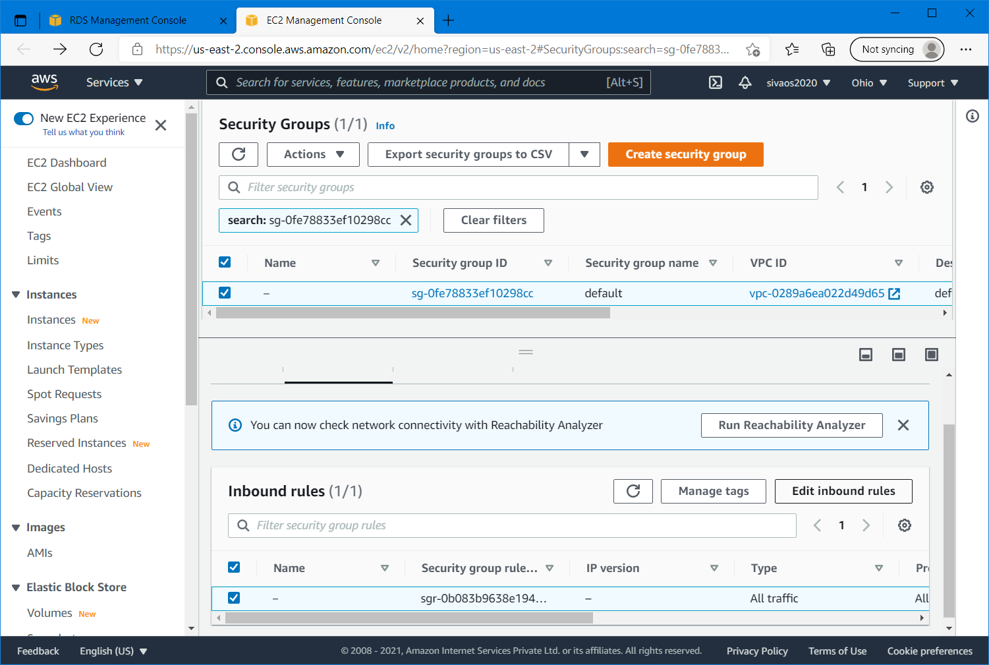

Step 20: Click on “Add rule” button , select “All traffic” for type, and “My IP” for Source. This will auto detect your ip and display it. Give a description as “PostgreSQL Inbound rule” and save rules.

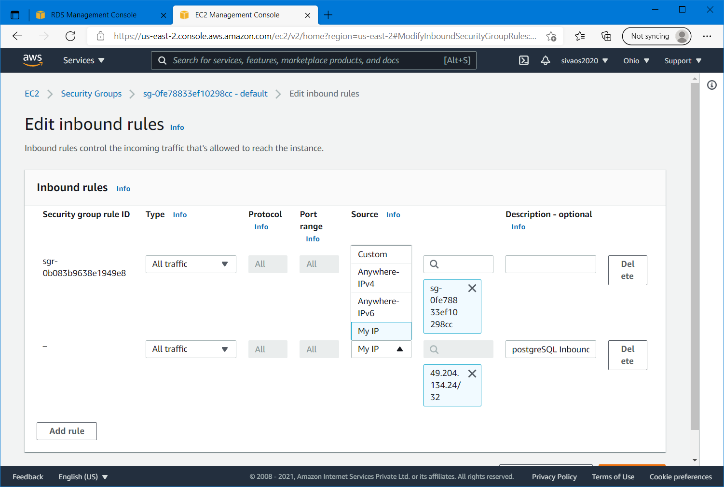

Step 21: Similarly add a new Outbound rule in the Outbound rules section by clicking the “Edit Outbound rules” button

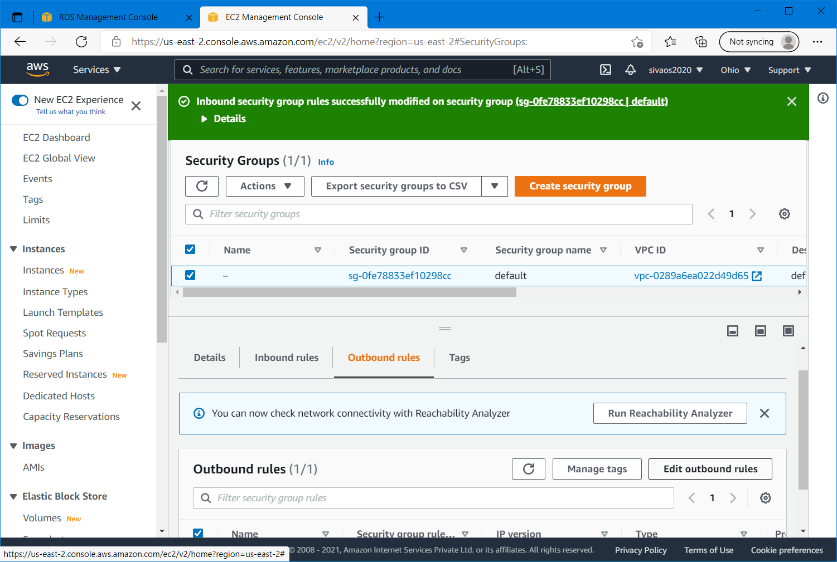

Step 23: Click on “Add rule” button , select “All traffic” for type, and “My IP” for Source. This will auto detect your ip and display it. Give a description as “PostgreSQL Outbound rule” and save rules.

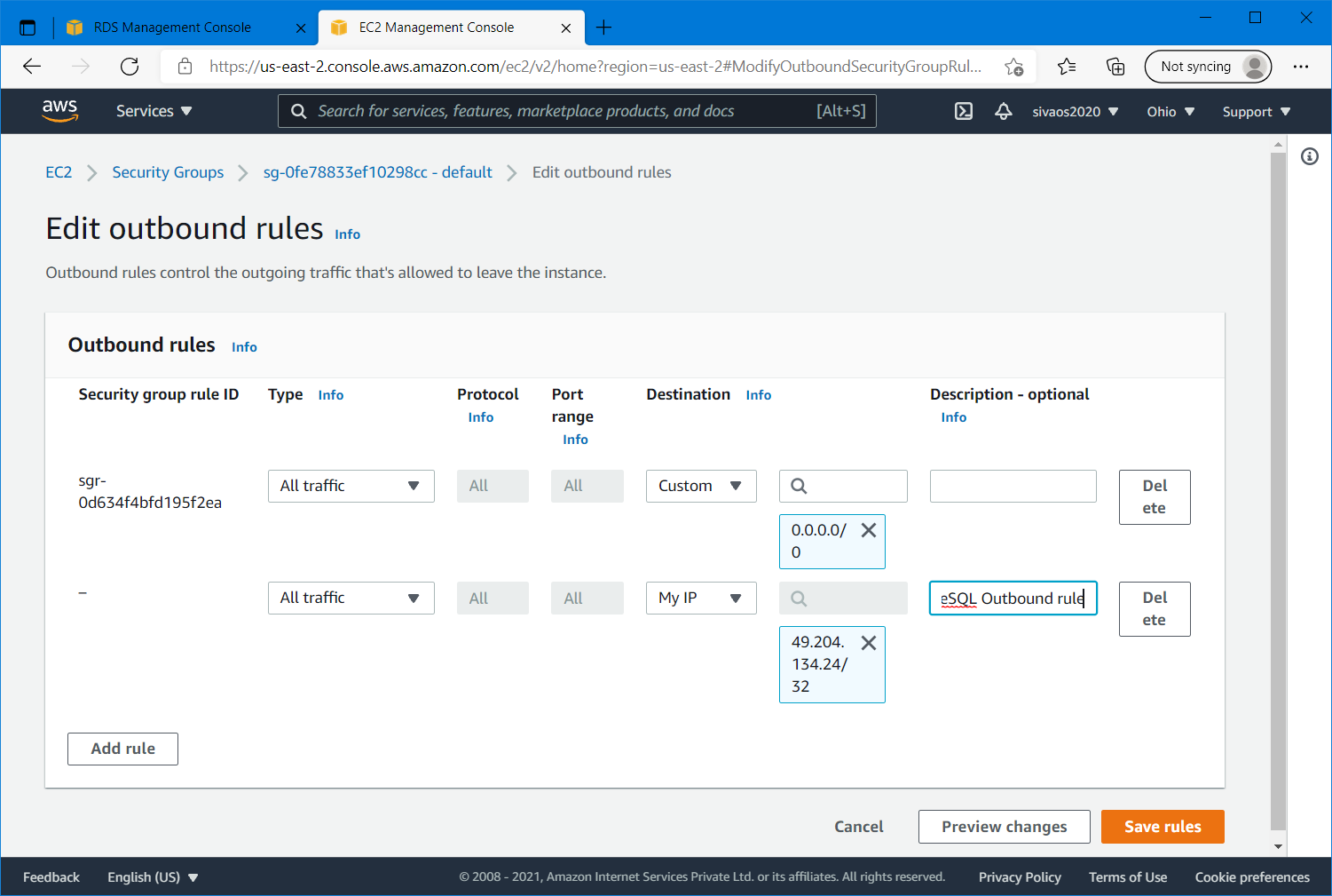

Step 24: Make sure that there are two Inbound rules and two outbound rules for your rds database as shown below.

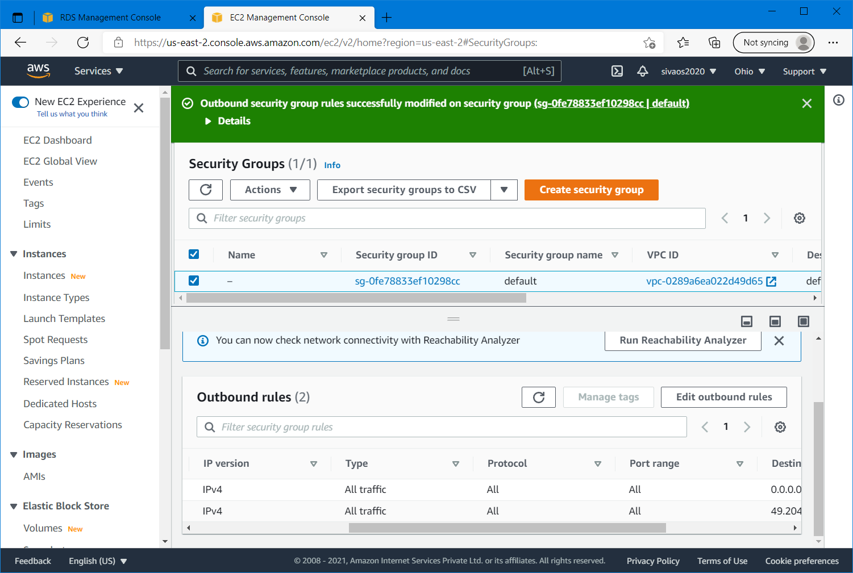

Step 25: Download and install the open source dbeaver from the following link and install it.

<https://dbeaver.io/download/> (choose the community version for your OS)

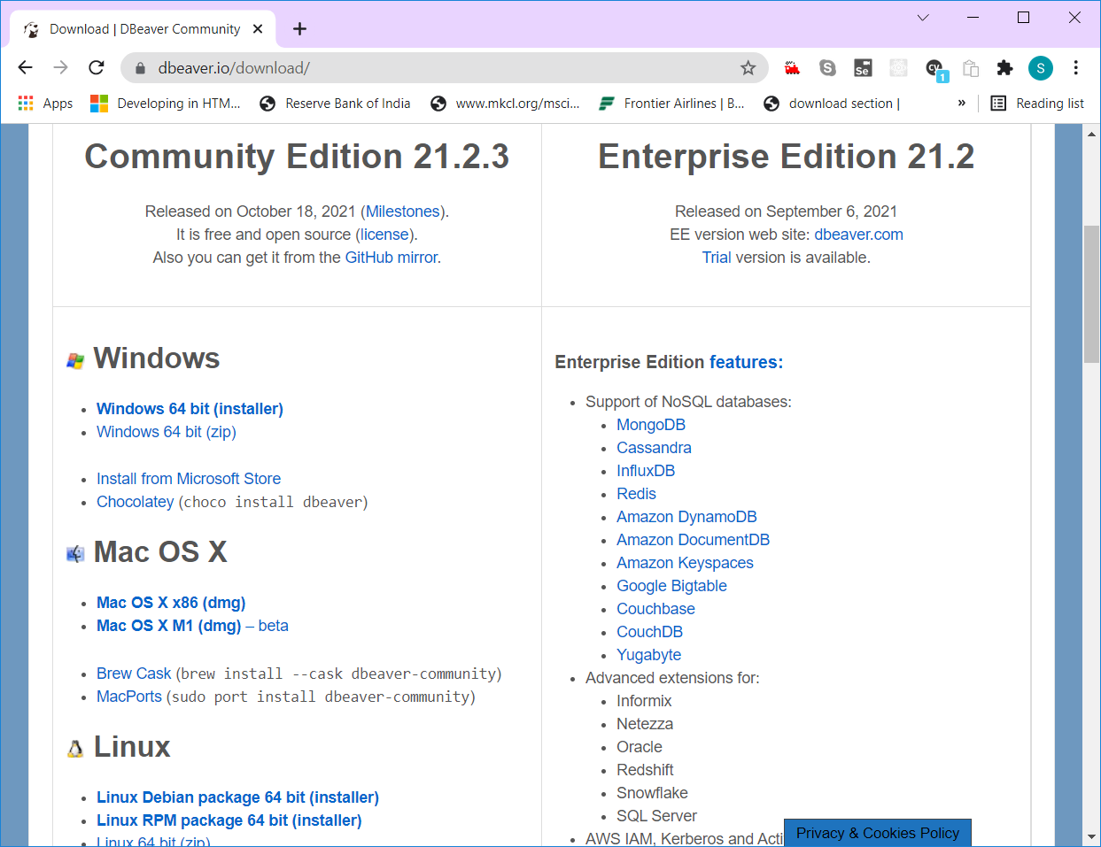

Step 26: Open the Dbeaver after installation

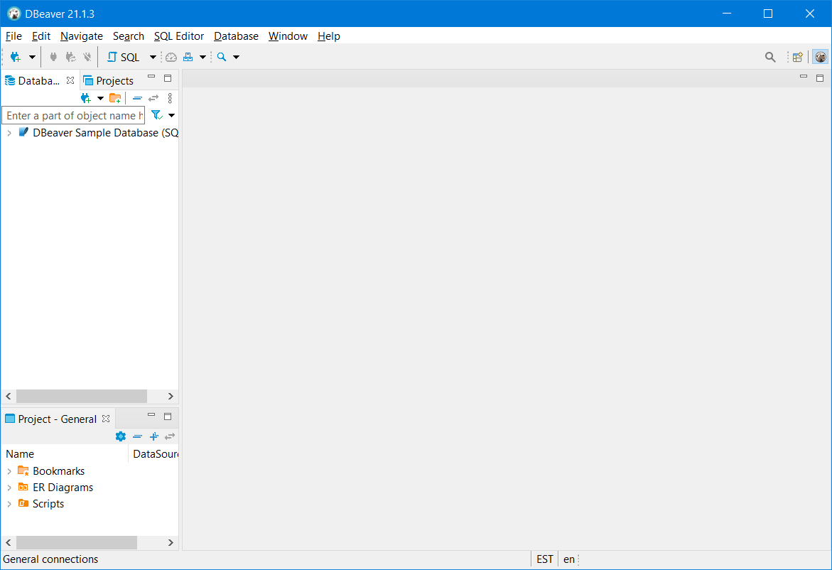

Step 27: Click on “New Database Connection” icon or select “New Database Connection” in Database menu.

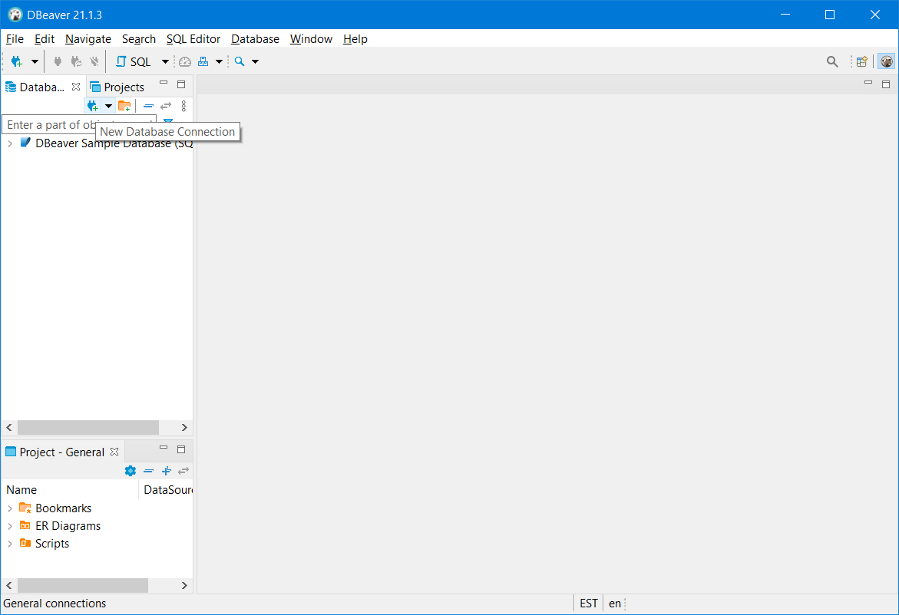

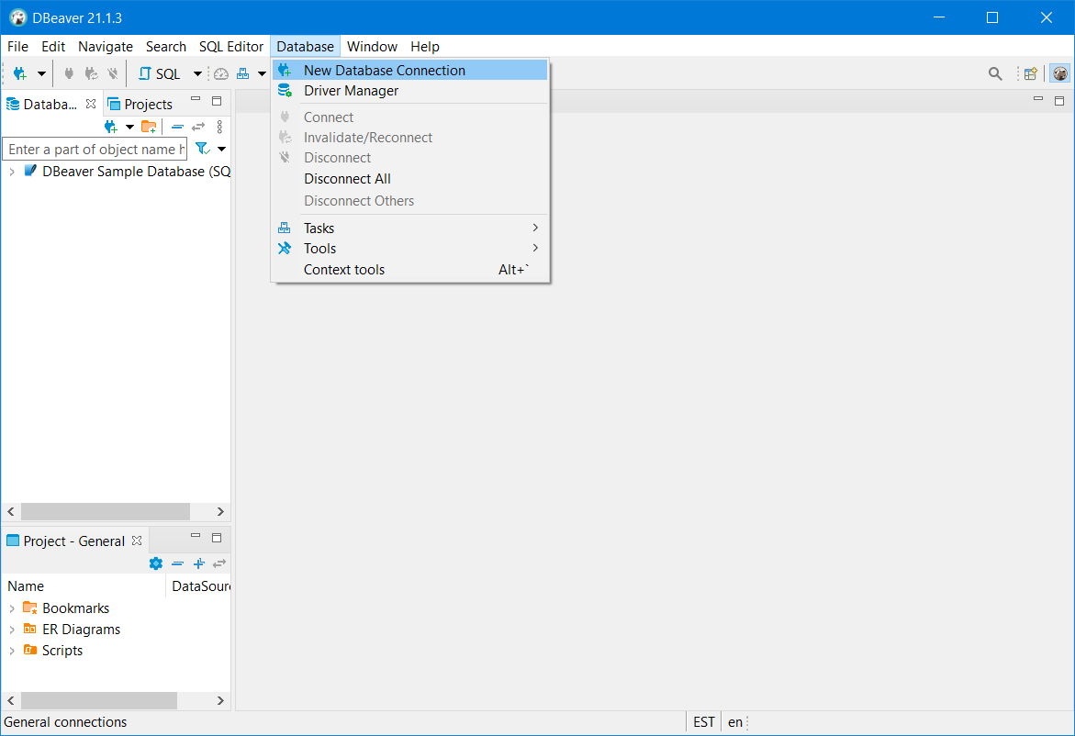

Step 28: select “PostgreSQL” in the Select your database wizard and click Next.

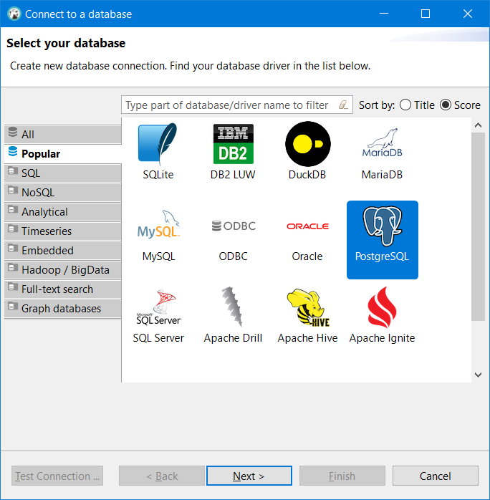

Step 29: Download the required Driver files automatically by clicking the “Download” button in the newly opened Driver Settings wizard.

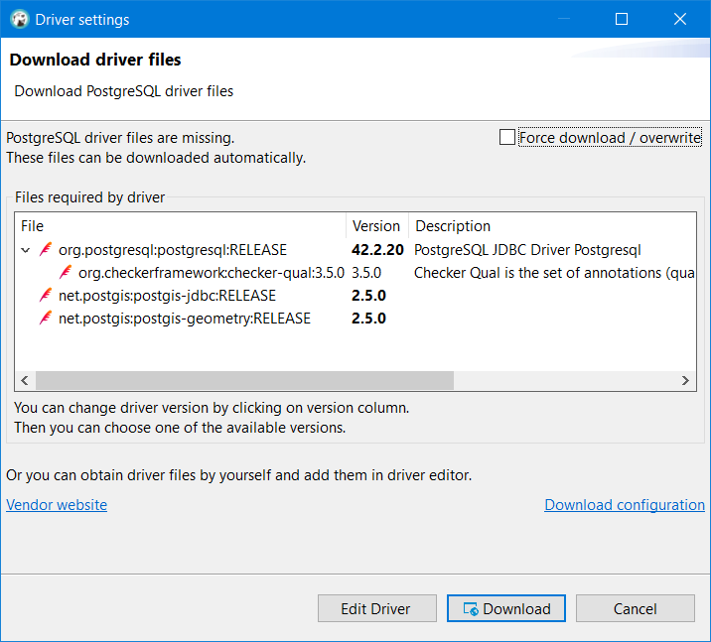

Step 30: Copy and paste the “Host” detail from your AWS RDS

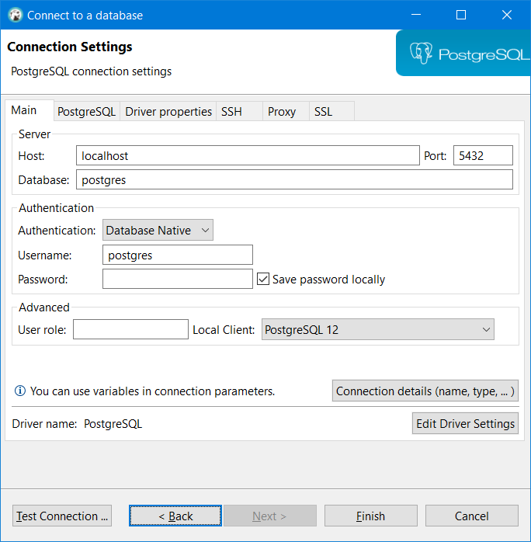

Step 31: After filling all the necessary data, click on “Test Connection” button and get “Connected” message as shown below. Click “Ok” and “Finish” button.

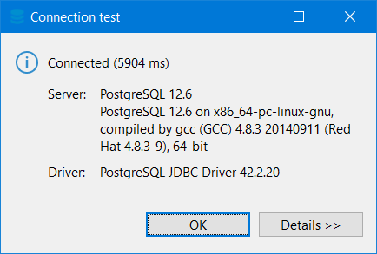

Step 32: You can explore the AWS-RDS PostgreSQL in the Dbeaver and add entities like table.

